Database Schema:

Social_Users holds user information. Social_Followings keeps track of which users a user is following. Social_Posts holds all posts made by users.

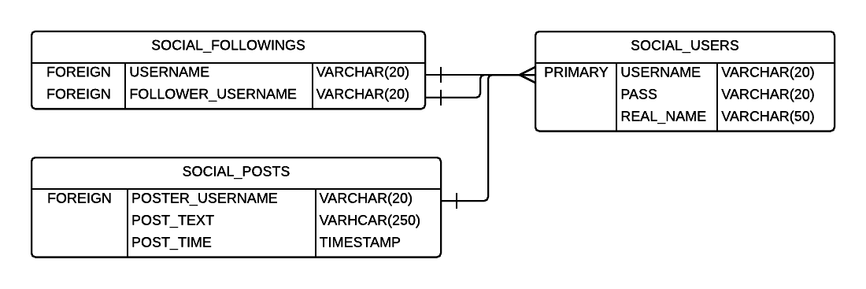

Indexing Information:

Social_Users Table:

SELECT COUNT(*) FROM MAKS202.SOCIAL_USERS WHERE USERNAME = ? AND PASS = ?;

Authorization for user login. Before index:

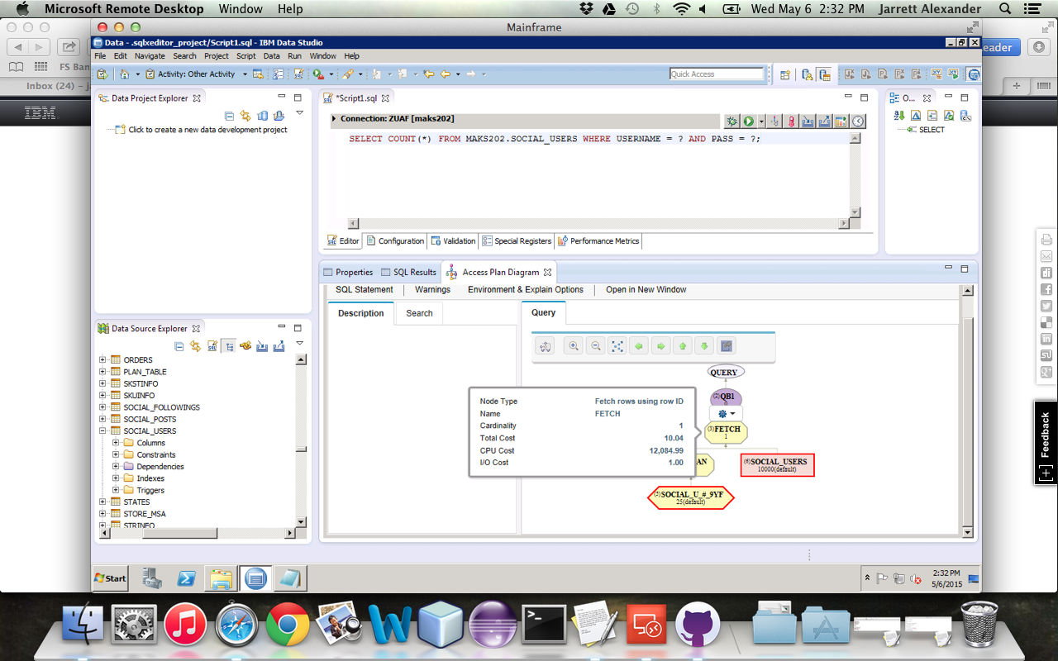

After index:

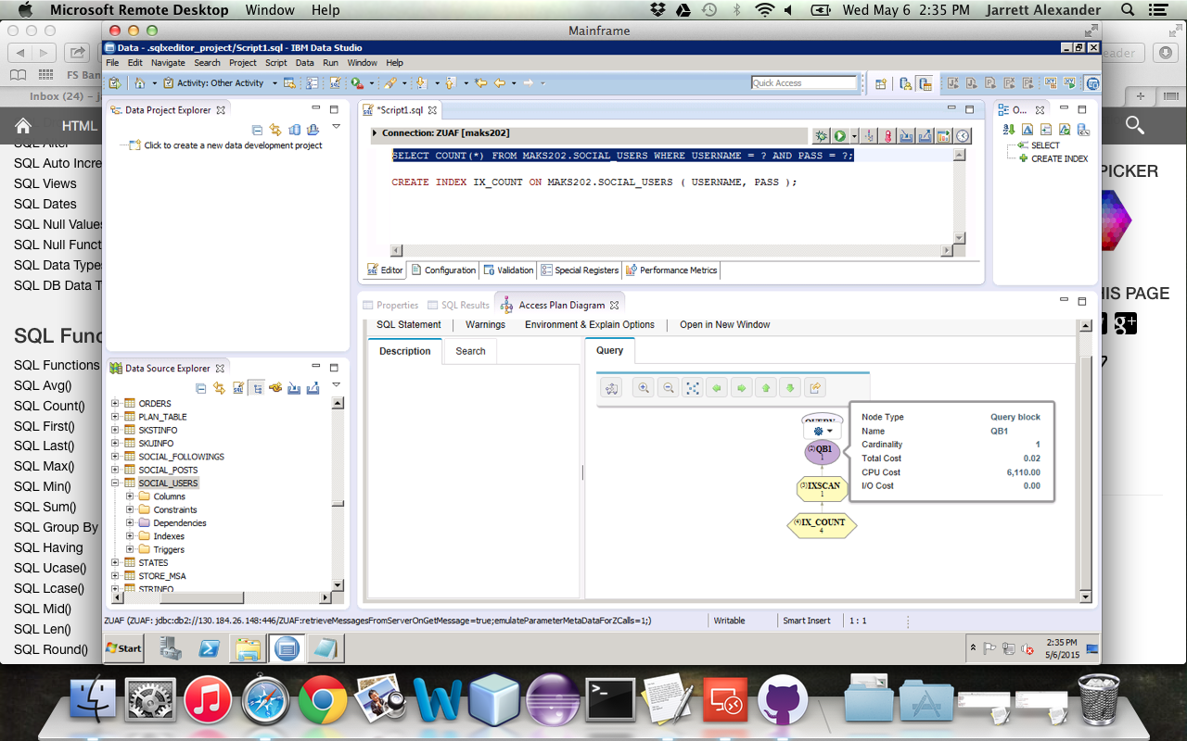

SELECT * FROM MAKS202.SOCIAL_USERS WHERE USERNAME = ?;

Retrieving a user by username. Before index:

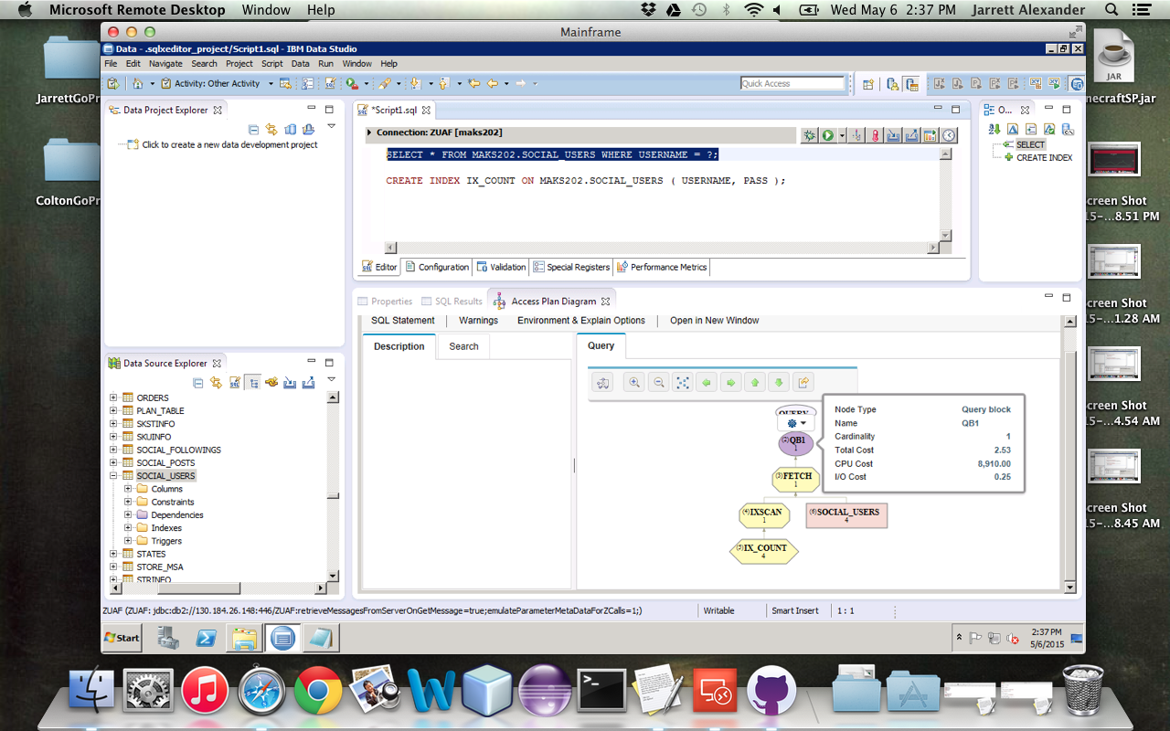

After index. I believe there’s not a change because username is the primary key for this table.

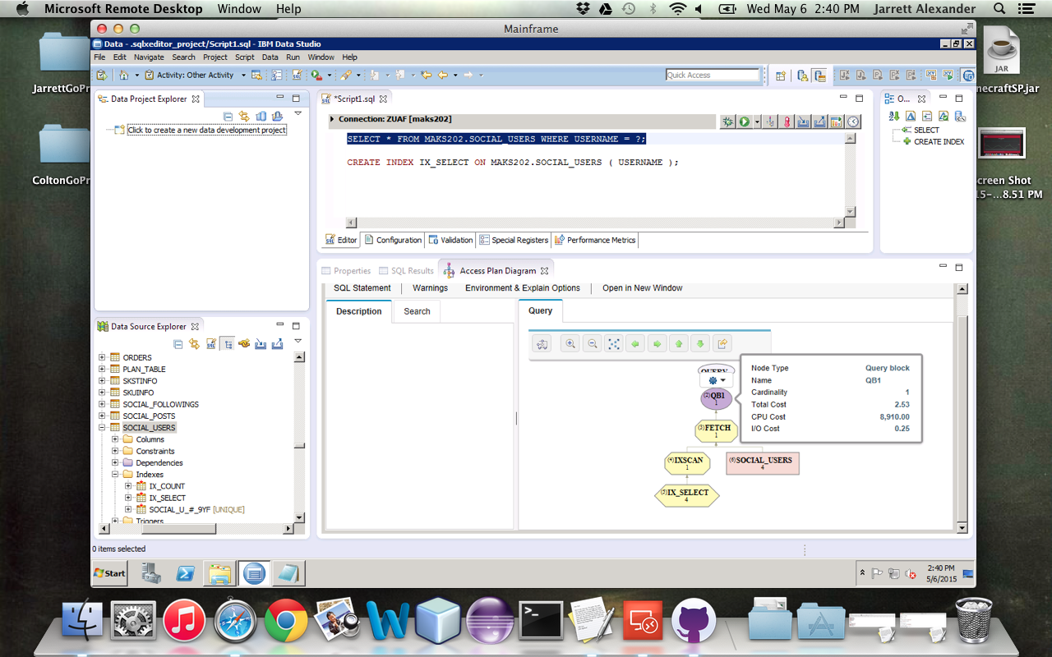

Social_Followings table:

SELECT * FROM MAKS202.SOCIAL_FOLLOWINGS WHERE USERNAME = ?;

Retrieving following info by username. Before index:

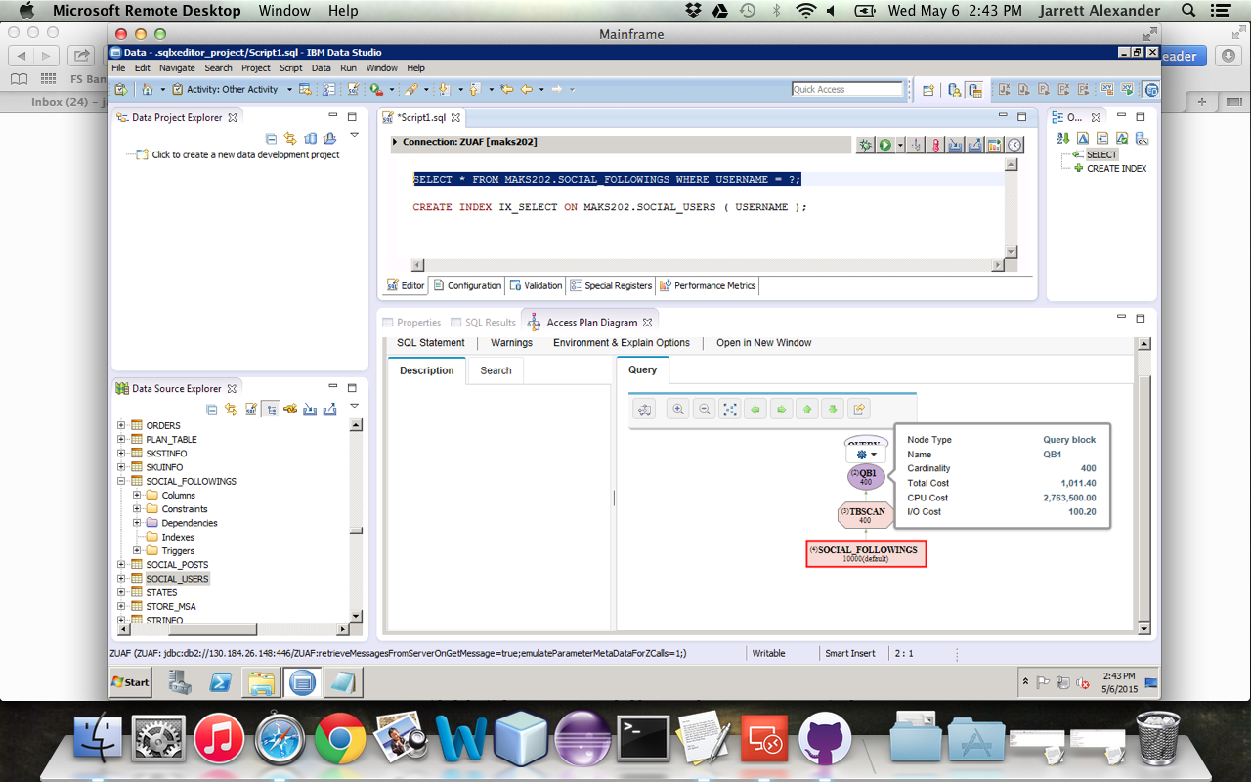

After index:

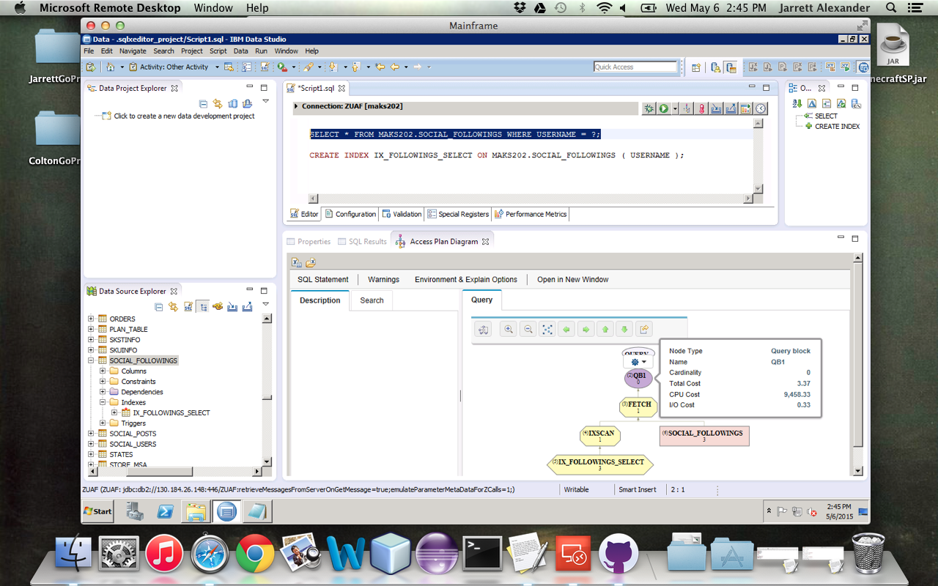

Social_Posts table:

SELECT * FROM MAKS202.SOCIAL_POSTS WHERE POSTER_USERNAME = ?;

Retrieve all posts by user. Before index:

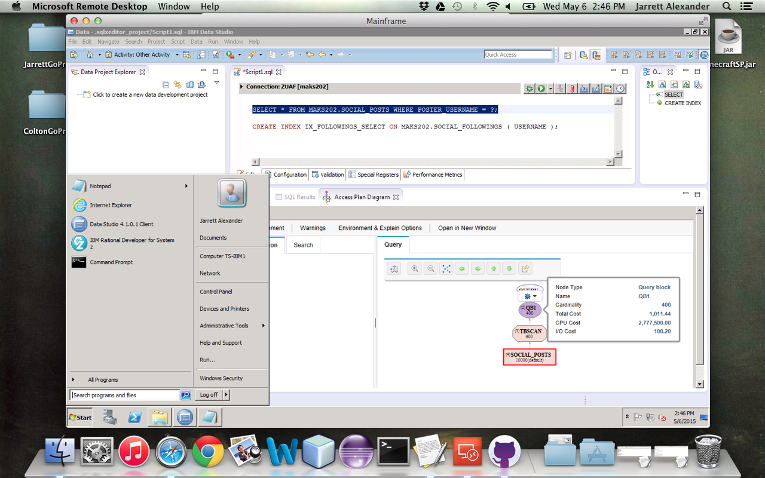

After index:

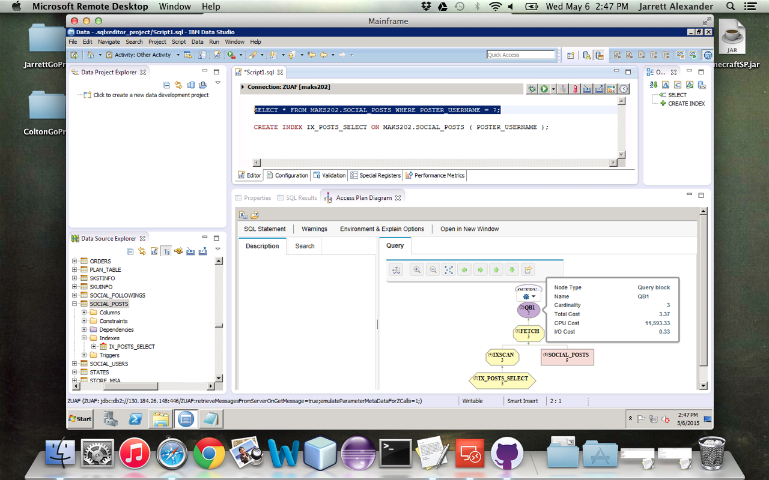

SQL Not Indexed:

I read that insert statements run slower the more indexes there are on a table, so I did not index the insert statements.

INSERT INTO MAKS202.SOCIAL_USERS( USERNAME, PASS, REAL_NAME ) VALUES ( ?, ?, ? );

INSERT INTO MAKS202.SOCIAL_FOLLOWINGS VALUES ( ?, ? );

INSERT INTO MAKS202.SOCIAL_POSTS VALUES ( ?, ?, CURRENT_TIMESTAMP );